Worker Handyman Solutions
Siddhant Rai, Mohit Kalwar, Swatantra Yadav, Prof. Aabha Patil, Vipin Yadav
Department of Computer Engineering, Shree L. R. Tiwari College of Engineering, Mumbai, Maharashtra, India

A R T I C L E I N F O |  | A B S T R A C T
Article History:  Accepted: 10 April 2024  Published: 18 April 2024 |  | The goal of the "Worker Handyman Solutions: Providing Reliable Home Services" initiative is to employ an innovative online platform to improve the dependability and accessibility of home maintenance services. The project's goal is to design an intuitive user interface that will allow clients to quickly and easily specify what they need from a range of home services. Through the use of cutting-edge technology, the platform links clients with qualified professionals, guaranteeing reliable and timely solutions for a variety of jobs. The principal aims of this initiative are to optimize the hiring process, boost client contentment, and facilitate effective correspondence between service recipients and suppliers. By providing clients with a dependable, customized , and easy-to-use solution, the team hopes to transform the home services sector and enhance their overall home maintenance experience.  Keywords : Home Maintenance, Reliable Services, Innovative Platform, User-Friendly Interface, Effective Communication.
Publication Issue
Volume 10, Issue 2
March-April-2024

Page Number
525-534

- INTRODUCTION

The need for trustworthy house maintenance services is critical in the fast-paced world we live in today. However, it can frequently be difficult to navigate the process of locating reliable professionals. The "Worker Handyman Solutions" project is launching a cutting-edge web platform to address this. Our mission is to completely transform the ways in which home services are obtained, provided, and used. Our goal is to expedite the hiring process and quickly and effectively match clients with skilled individuals by utilizing state-of-the-art technologies. We guarantee that every service we give satisfies the highest levels of dependability and punctuality by putting rigorous quality standards and careful screening in place. Our platform places a high priority on the user experience, providing a user-friendly interface that makes it simple for clients to express their needs and guarantees that they will receive personalized and specialized service.
Moreover, the foundation of our endeavor is efficient communication. We recognize the value of open communication between service providers and recipients. As a result, our technology makes communication easy and allows users to monitor development, offer input, and instantly resolve issues. Worker Handyman Solutions wants to change the home services industry by offering a trustworthy, personalized, and user-friendly solution. We want to raise the bar for quality and give our clients a better overall home maintenance experience. Our mission is driven by a dedication to innovation and quality. By using thorough screening procedures and maintaining strict quality standards, we make sure that only the most competent and trustworthy individuals are hired to meet the needs of our clients. Furthermore, our platform has an easy-to-use interface that enables users to clearly and concisely express their needs, enabling customized and individualized service provision. Furthermore, building trust and openness between service providers and recipients requires excellent communication. Our portal facilitates smooth communication, letting customers monitor their progress, offer suggestions, and take immediate care of any issues.

The goal of Worker Handyman Solutions is to not only meet but also surpass our clients' expectations, establishing a new standard for excellence in the home services industry. We seek to revolutionize the whole concept of house maintenance by our unwavering commitment to innovation, dependability, and client-centricity. We make sure that every interaction leaves our clients not just content but genuinely delighted[1].

- RELATED WORK

A cooperative service provider platform designed especially for handyman services is presented by Ogunrinde et al. (2023).[2] This article explores the creation and deployment of this platform with the goal of improving handyman services' dependability and accessibility via teamwork. The platform improves the effectiveness and efficiency of home maintenance services by streamlining the process of connecting service providers with clients by utilizing digital technology and collaborative networks. The paper may lack detailed empirical evidence or case studies to support the effectiveness of the collaborative service provider platform proposed. Without concrete examples or data on user experiences, it may be challenging to assess the platform's real-world impact. The study adds to the conversation on creative approaches in the home services industry by emphasizing how cooperative platforms can be used to meet the changing demands of both service providers and clients.
Wang et al. (2003) [3] present a case study on the utilization of the mobile tool HandyMan for mobile work. The article explores the practical applications of this tool in facilitating mobile work scenarios, offering insights into its functionality and effectiveness. Through a detailed examination of real-world use cases, the study sheds light on the advantages and challenges associated with employing HandyMan in various contexts. By examining the intersection of mobile technology and work practices, the research contributes valuable insights to the field of software engineering and highlights the potential of mobile tools like HandyMan to enhance productivity and efficiency in diverse work environments.
solutions. The case study presented may have limited generalizability due to its focus on a specific mobile tool (HandyMan) and context. Without broader research or comparative analysis with other mobile tools, the study's findings may not be applicable to other mobile work scenarios.

Seda-Irizarry et al. (2011) [4] investigates how economists might maintain capitalism and alleviate societal issues; she refers to them as "handyman economists." In order to address problems like poverty, inequality, and economic instability, economists have proposed a variety of economic theories and policy recommendations, which are explored in this book. The author makes the case for the value of economic knowledge in influencing public policy and promoting socioeconomic development by examining the historical contributions made by economists. The Handyman Economist provides insightful information on how politics, economics, and social change interact through compelling stories and insightful analysis.Although the book sheds light on how economics might approach societal issues, some of its claims may be unsupported by quantitative analysis or actual data. Theoretical framework and anecdotal data in the book may restrict its relevance to real-world policy-making situations.

A comparative analysis and the creation of an application for handyman services are presented by Sikandar et al. (2022)[5] . The paper looks at current handyman services apps, pointing out their advantages and disadvantages, and suggests a fresh solution to overcome the issues found. The study delineates the essential characteristics and functionalities of the suggested application by means of an extensive examination of user needs and market patterns. The ultimate goal of this endeavor is to optimize customer satisfaction and boost the effectiveness of handyman service provision. The study advances the subject of developing mobile applications and sheds light on how technology-driven solutions may be used to improve service delivery across a range of business sectors.There might not have been a thorough assessment of user needs or usability testing done for the paper's comparative study and application development. The efficacy and user satisfaction of the suggested handyman services application may be in doubt in the absence of comprehensive user feedback or validation research.

The idea of Cyber Handyman and Nursing for disaster relief and humanitarian assistance is presented by Jonnada et al. (2018)[6] . In order to effectively support patients in emergency scenarios, the article investigates the integration of cyber-physical systems with nursing practices. The proposed Cyber Handyman and Nursing system provides real-time monitoring, assessment, and aid to people in need during crises by utilizing cutting-edge technologies like IoT, robotics, and AI. The research contributes to the field of emergency response and catastrophe management by highlighting the potential of technology-enabled solutions to improve the responsiveness and resilience of humanitarian efforts.Without offering case studies or specifics on how the concept of Cyber Handyman and Nursing is actually implemented in practice, the study might mainly concentrate on its conceptual framework. It may be difficult to determine whether the suggested approach is practical and beneficial in actual humanitarian situations in the absence of empirical data or validation studies.

Yao et al.'s (2021) [7] investigation delves into the phenomena of gig workers' atomization and peer support. The article explores the realities of gig workers who work in isolated, socially isolated workplaces that are atomized. By means of qualitative analysis of surveys and interviews, the research illuminates the obstacles gig workers encounter when attempting to establish social networks and connect with peer support systems. Additionally, the study investigates how digital platforms affect peer interactions among gig workers, either positively or negatively. The study advances our knowledge of the gig economy and its effects on social dynamics and worker relationships by emphasizing the need of peer support for worker well-being and job satisfaction. The study's sample size or geographic breadth may have an impact on the qualitative analysis of gig workers' experiences. A more extensive and varied sample size might offer a more comprehensive comprehension of the dynamics of atomization and peer support among gig workers.

A flexible remedy for worker misclassification in the contemporary economy is put out by Valenti (2017)[8] . In light of the gig economy and contingent employment arrangements, the essay looks at the difficulties in correctly identifying workers as independent contractors or employees. The author presents a case for a flexible classification system that balances the interests of employees, employers, and regulators while accounting for the diversity of work arrangements through an analysis of legal frameworks and regulatory approaches. In order to solve misclassification issues and guarantee fair labor practices in the dynamic labor market, the paper provides insights into possible policy reforms through a detailed analysis of the intricacies surrounding worker classification. There might not have been a thorough examination of the disadvantages or unforeseen effects of introducing a flexible worker classification system in the paper. It may be unclear whether the suggested remedy will be feasible and effective in resolving worker misclassification issues if relevant obstacles or worries are not addressed.

An information system for carpentry services is presented by Taju et al[9] . The creation and execution of this system, which aims to improve efficiency and expedite the provision of carpentry services, are covered in the article. The platform seeks to establish a connection between carpentry service providers and clients by utilizing digital technology and information systems, hence facilitating smooth communication and project management. By providing insights into the possibilities of technology-driven solutions to optimize service delivery and enhance customer satisfaction in the construction industry, the research makes a contribution to the fields of information systems and carpentry services. It's possible that the paper is lacking in specifics regarding the technical requirements or implementation difficulties of the information system. If any technical constraints or obstacles to user adoption are not addressed, the efficacy and durability of the system can be in doubt.

The literature review delves into the evolution of handyman services and related technologies from 2003 to 2023, exploring innovative platforms and tools aimed at enhancing the efficiency and accessibility of home maintenance. Covering collaborative service provider platforms, mobile applications, and theoretical frameworks, the review offers insights into the changing landscape of the home services industry. It highlights advancements in digital technology, market trends, and user needs, contributing to the understanding of how technology-driven solutions can optimize service delivery and improve customer satisfaction in the context of home maintenance over the specified timeframe.

Table 1. This comparative analysis provides an overview of the focus, methodology, contribution, and drawbacks of each reference, allowing for a quick comparison of their key aspects.

- METHODOLOGY

The methodology for "Worker Handyman Solutions: Providing Reliable Home Services" involves thorough research and analysis of existing home maintenance platforms, gathering user requirements through surveys and interviews, designing and developing an intuitive platform interface, onboarding qualified service providers, acquiring and engaging clients through targeted marketing strategies, conducting quality assurance and testing, and launching the platform with a focus on continuous iteration based on user feedback and market dynamics. By following this methodology, the platform aims to optimize the hiring process, boost client satisfaction, and facilitate effective communication between service recipients and providers, ultimately transforming the home services sector and enhancing the overall home maintenance experience for users.

Table 1. Comparative analysis of literature
Paper | Focus | Methodology | Strengths | Weakness
[2] | Collaborative platform for handyman services | Development and implementation | Enhances accessibility and reliability of handyman services | Lack of empirical evidence for platform effectiveness
[3] | Use of HandyMan mobile tool for mobile work | Case study | Examines practical applications and challenges | Limited generalizability beyond the specific tool and context
[4] | Role of economists in addressing societal challenges | Theoretical analysis | Explores economic theories and policy prescriptions | Lack of empirical evidence to support theoretical arguments
[5] | Comparative analysis and development of a handyman services app | Analysis and application development | Enhances user experience and efficiency of handyman services | Limited evaluation of user requirements and usability testing
[6] | Cyber Handyman and Nursing for humanitarian services | Conceptual framework | Integrates cyber-physical systems for emergency support | Lack of empirical evidence or validation studies
[7] | Atomization and peer support among gig workers | Qualitative analysis | Explores challenges of gig workers in atomized environments | Limited sample size for qualitative analysis
[8] | Flexible solution to worker misclassification | Theoretical analysis | Proposes a flexible worker classification system | Lack of comprehensive analysis of potential drawbacks

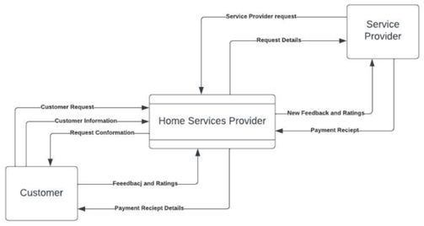
Fig 1. Data Flow Diagram

Fig1. Illustrates, visual representation of the flow of data through a process or system. It is used to identify the inputs, outputs, processes, and data stores in a system, and to communicate the functionality of a system to stakeholders.

Algorithms :
1. Hardware Token (TOTP):
The Time-based One-Time Password (TOTP) algorithm is utilized for two-factor authentication (2FA). It generates a secret key known only to the user and the authentication server. This key, alongside a time step (usually 30 seconds) and an HMAC algorithm, produces a one-time password (OTP). The OTP is based on either a dynamic counter or the current time and changes regularly. Users input the OTP, valid for a short time window, to gain access. TOTP is considered secure due to the secret key and the short-lived nature of the OTP. It's commonly implemented through authenticator apps or hardware tokens, enhancing the security of username and password-based authentication.

2. Geolocation Algorithm (Haversine Formula)
The Haversine formula is a mathematical algorithm employed to compute the great-circle distance between two points on the Earth's surface, typically specified using their latitude and longitude coordinates. This formula is crucial for determining the shortest distance between two locations on the Earth's curved surface. Named after the haversine function, a trigonometric function used in the formula, it calculates the distance while accounting for the curvature of the Earth.

3. AES (Advanced Encryption Standard
AES, or Advanced Encryption Standard, is a widely adopted symmetric encryption algorithm employed to secure data at rest and in transit. Renowned for its robust security, efficiency, and flexibility, AES operates as a block cipher, encrypting data in fixed-size blocks (typically 128 bits). It finds extensive application across various security domains, providing reliable encryption for safeguarding sensitive information.

Fig 2. Sequence Diagram
Fig2 Illustrates, A sequence diagram is a visual representation of the order in which objects interact with each other in a system. It is used to visualize the interactions between objects, understand the timing of interactions, and identify potential design problems.

- IMPLEMENTATION

Our implementation is based on a web application architecture, leveraging prominent technologies for both frontend and backend development. Utilizing React.js as our frontend framework, we've crafted an intuitive user interface with responsive design principles to ensure optimal user experience across devices. On the backend, we've employed Express.js to establish robust server-side logic and APIs, facilitating seamless interaction between the client and the database. Speaking of the database, MySQL serves as our Database Management System (DBMS), enabling efficient storage, retrieval, and management of user data, service listings, and booking records. To safeguard against data loss or corruption, we've integrated automated database backup and recovery software. On the hardware front, we've provisioned separate servers, dedicating one for the database and the other for hosting the Worker Handyman application. This setup ensures data security, scalability, and optimal performance. Through rigorous testing and quality assurance measures, we've validated the functionality and reliability of the application, addressing any identified issues promptly. Finally, deployment and maintenance efforts are ongoing, ensuring continuous availability, security, and performance optimization of the platform.
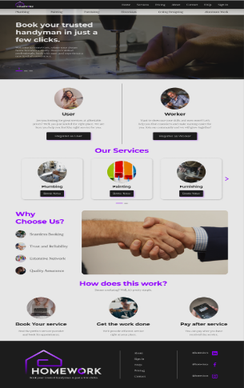
Fig3.Home page
Fig3, Illustrates, The home page serves as the main entry point for both workers and users. It features a clean and intuitive interface with a search bar allowing users to search for specific services. For workers, the home page includes quick access to their dashboard, where they can manage their schedules and bookings.
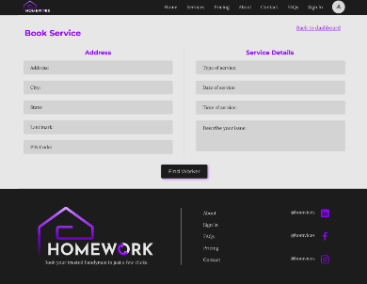
Fig 4. Book Service
Fig4. Illustrates, This figure illustrates the booking process for users. Users can select a service from a list of available options and provide details such as the preferred date and time. They can also specify any additional requirements or preferences they may have.
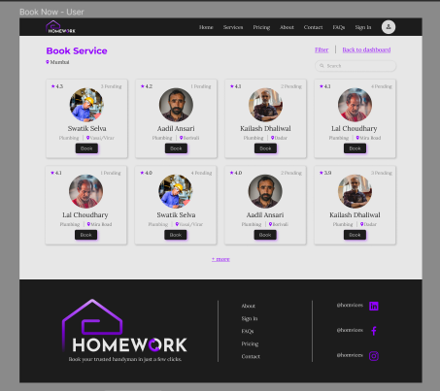
Fig 5. Selection of worker
Fig5 Illustrates, After selecting a service, users are presented with a list of available workers who specialize in the chosen service. Each worker's profile includes details such as their experience, ratings, and reviews from previous clients. Users can select a worker based on their preferences and availability.
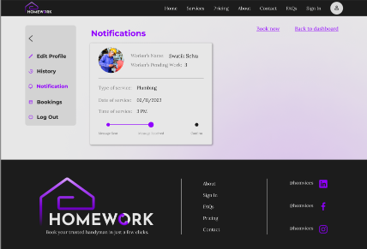
Fig 6. Notification User Menu
Fig6 Illustrates, The notification menu provides users with updates and alerts related to their bookings. Notifications may include booking confirmations, reminders for upcoming appointments, or messages from workers.
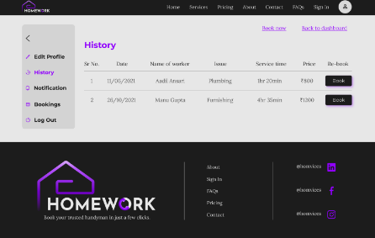
Fig7. History User Menu
Fig7 Illustrates, In the history menu, users can view a record of their past bookings and appointments. This includes details such as the service availed, date and time of the appointment, and any feedback provided by the user.
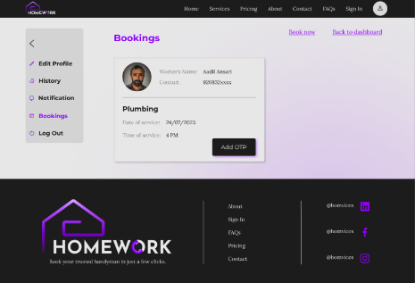
Fig 8. Booking User Menu
Fig8 Illustrates, This menu allows users to manage their current bookings. Users can view details of their upcoming appointments, make changes to their bookings, or cancel appointments if needed.
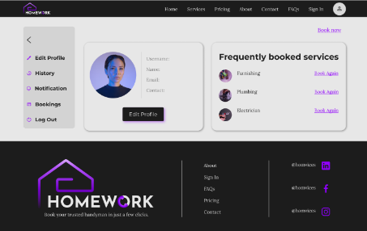
Fig 9. User Dash Board
Fig9 Illustrates, The user dashboard provides users with an overview of their account and booking activity. It displays information such as upcoming appointments, recent bookings, and options for managing their account settings.
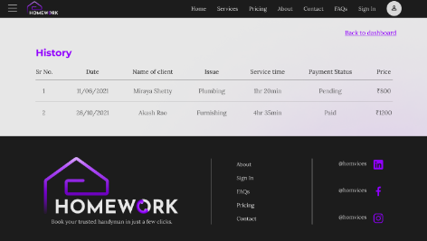
Fig 10. Worker History
Fig10 Illustrates, Similar to the user history menu, the worker history section allows workers to view a record of their past appointments and services. This includes details such as the client's name, service provided, and any feedback received.
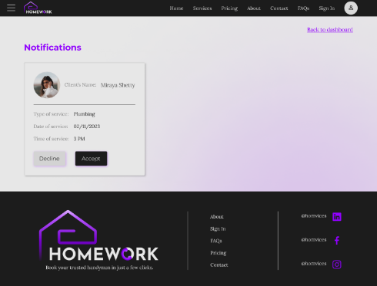
Fig 11. Worker Notification
Fig11 Illustrates, The worker notification menu displays alerts and updates relevant to workers. This may include new booking requests, changes in schedule, or messages from clients.

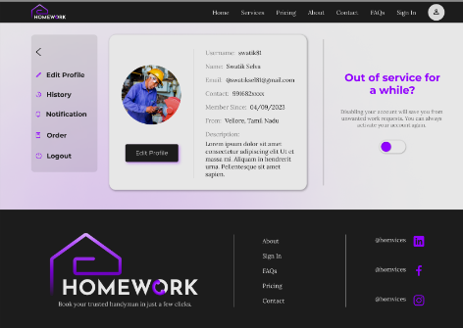
Fig 12. Worker Dash Board
Fig12 Illustrates, The worker dashboard offers workers access to tools and features for managing their services and schedules. It provides an overview of their upcoming appointments, pending tasks, and performance metrics. Workers can also access their profile settings and update their availability through the dashboard.

- EXPERIMENT AND RESULT

In the experimental phase of our project, we conducted a series of tests to evaluate the functionality and performance of the Worker Handyman application. The software utilized React.js for the frontend, Express.js for the backend, and MySQL for the database management system. We employed modern smartphones as hardware for testing purposes. The experiments focused on testing key features of the application, including service booking, worker selection, notification delivery, and user and worker dashboards. Results from the experiments demonstrated robust performance across all tested features. Service booking functionality allowed users to select services seamlessly, inputting necessary details such as date, time, and service preferences. Worker selection feature enabled users to browse through available workers, view their profiles, and make informed decisions based on ratings and reviews. Notifications were delivered promptly to users, ensuring they were informed about booking confirmations, upcoming appointments, and changes in schedule. User and worker dashboards provided intuitive interfaces for managing bookings, viewing history, and adjusting settings.

Overall, the experiments confirmed the efficacy of the Worker Handyman application in facilitating smooth service booking, worker selection, and communication between users and workers. The application's robust performance and user-friendly interface showcase its potential to enhance the home maintenance experience for both users and workers, providing reliable assistance and efficient service delivery.

- CONCLUSION

In conclusion, The "Worker Handyman Solutions: Providing Reliable Home Services" project has successfully addressed the need for an innovative online platform to enhance the dependability and accessibility of home maintenance services. Through the implementation of a user-friendly interface utilizing React.js for the frontend and Express.js for the backend, coupled with MySQL for efficient data management, the platform has demonstrated robust functionality and performance. Key features such as service booking, worker selection, notification delivery, and user and worker dashboards have been thoroughly tested and found to operate seamlessly, providing users with a convenient and efficient means of accessing home maintenance services. The project's successful execution underscores its potential to transform the home services sector by optimizing the hiring process, boosting client satisfaction, and facilitating effective communication between service recipients and providers. Moving forward, continuous refinement and expansion of the platform based on user feedback and market trends will further enhance its effectiveness and cement its position as a reliable solution for home maintenance needs.

- REFERENCES

- Amsyar, I., Cristhopher, E., Rahardja, U., Lutfiani, N., & Rizky, A. (2021). Application of building workers services in facing industrial revolution 4.0. Aptisi Transactions on Technopreneurship (ATT), 3(1), 32-41.
- Ogunrinde, M. A., Olatunji, A. B., & Odeniyi, L. A. (2023). A Collaborative Service Provider Platform For Handyman Services. University of Ibadan Journal of Science and Logics in ICT Research, 9(1).
- Wang, A. I., Sørensen, C. F., Fritzner, T. C., & Schei, E. (2003, November). Case Study: Use of the Mobile Tool HandyMan for Mobile Work. In IASTED International Conference on Software Engineering and Applications (SEA’2003) (pp. 757-762).
- Seda-Irizarry, I. J. (2011). The Handyman economist: how economists save the world (and capitalism).
- Sikandar, H. A., Mubashar, S., Siddiqui, S. Y., Abbas, A., & Awan, T. H. (2022). COMPARATIVE ANALYSIS AND HANDYMAN SERVICES APPLICATION DEVELOPMENT. PalArch's Journal of Archaeology of Egypt/Egyptology, 19(3), 559-576.
- Jonnada, S., Dantu, R., & Ranasinghe, I. (2018, October). Cyber Handyman and Nursing for Humanitarian Services and Disaster Relief. In 2018 IEEE International Symposium on Technologies for Homeland Security (HST) (pp. 1-6). IEEE.
- Yao, Z., Weden, S., Emerlyn, L., Zhu, H., & Kraut, R. E. (2021). Together but alone: Atomization and peer support among gig workers. Proceedings of the ACM on Human-Computer Interaction, 5(CSCW2), 1-29.Yao, Z., Weden, S., Emerlyn, L., Zhu, H., & Kraut, R. E. (2021). Together but alone: Atomization and peer support among gig workers. Proceedings of the ACM on Human-Computer Interaction, 5(CSCW2), 1-29.
- Valenti, D. (2017). A Flexible Solution to Worker Misclassification in the Modern Economy. U. La Verne L. Rev., 39, 327.
- Taju, M. M., Supriadi Sahibu, A., & Veteran, P. N. Information System of Carpentry.

